
Opename_MVP_Plan_v6

Overview

Opename (ON) is a team collaboration platform for evolving and concurrently evaluating a question's answer-options, in real-time. Participants respond to the session-initiator's session question, by voting in real-time, for multiple answer/strategy options, which can also be created and edited by the participants in real-time.
Thus, participants vote for answer options, while discuss them via video-conference, and while refining the session's answer-option name/description pairs. Only the registered initiator can define and refine the session question, because this can easily throw-off past voting.
All session participants must be pre-gated by the session-initiator, and all participants use a pseudonym/avatar to which Function tags and participant endorsements attach.
The platform will be marketed to founders, product teams, executive boards, advisory councils and organizations that prefer meritocratic decision-making.

Licensed Integration into GroupBuild

The OpeName voting engine can be licensed for integration into third-party platforms, such as GroupBuild, allowing enhanced democratic functionality for group management. In this scenario, GroupBuild's Group-Initiator and their within-Group Moderator(s), could embed the OpeName voting module directly into the Group profile and/or Group-chat dialogue.
Thus, an OpeName module integrated into GroupBuild, would enable:
1. Polling of Group Members in real-time, or asynchronously, regarding key strategic decisions, such as event planning, campaign direction, or Group-level policy changes.
2. Evolve Strategy Options Collaboratively, allowing members to co-edit answer/strategy choices live, rather than just selecting from predefined options.
3. Weight Votes by Peer Recognition, using the [Function + Qualifier + RepTag] weighting model to ensure the most credible voices carry proportional influence, based on their contributions and group-acknowledged expertise.
4. Export White-Label Reports summarizing Group-member preferences, discussion highlights, and inferred strategic direction—usable for both public-facing announcements and Group-internal documentation.
5. Avoid Long-Term Data Retention, as all voting-session data is transient, unless specifically saved by the Group-initiator, thus helping GroupBuild to maintain a lean data compliance model.
This integration allows civic and advocacy groups within GroupBuild to make use of a meritocratic, pseudonym-based deliberation engine that supports more nuanced and participatory decision-making than traditional polling/voting systems:
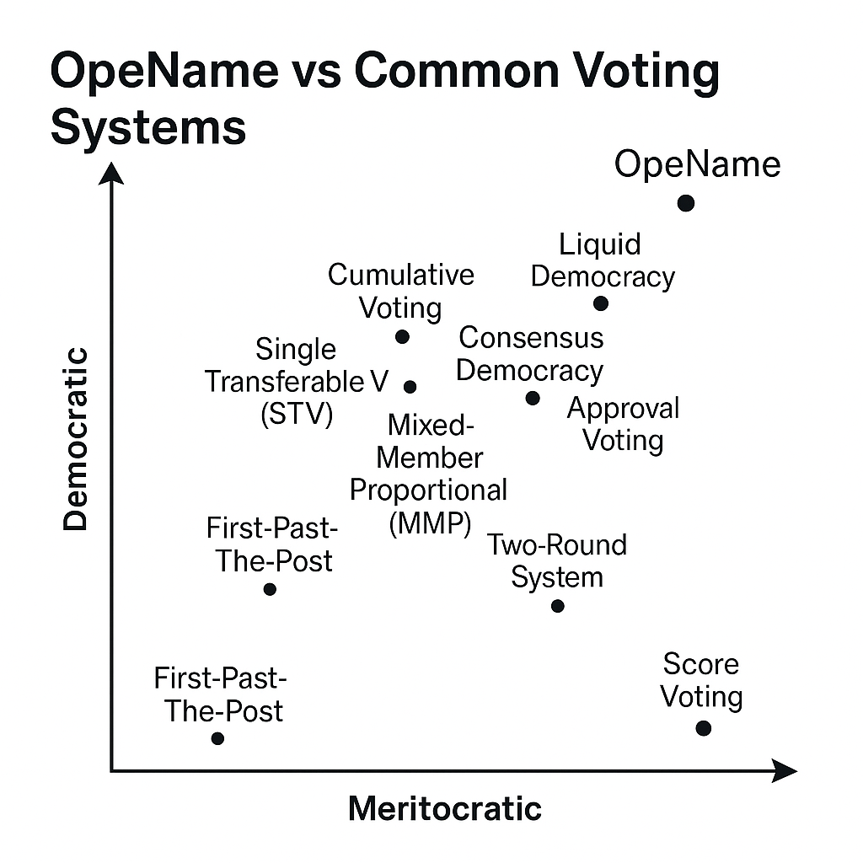
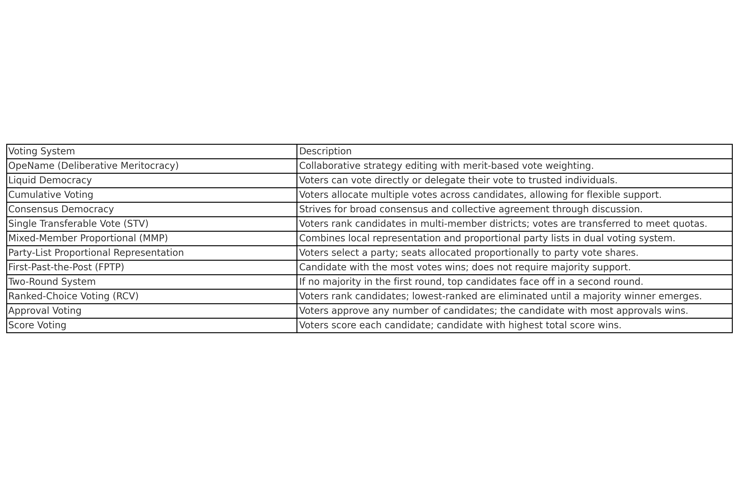

Service Description

The system supports:
- Named answer/strategy options tied to a session question
- Peer trophy-voting for answer/strategy propositions
- Peer star-endorsement of other participant's Function + Qualifier
- Anonymous access to landing page, which shows an example session in progress, and a sample Session Summary, without visitor needing to login
- Registered access to session creation page, including Question creation/editing.
- Anonymous access to combined Question and Answer Options page, including session discussions and current vote/endorsement statistics, (access dependent on session-initiator consent)
- White-label (no logo), downloadable summaries for sharing by session-initiator
- No permanent data retention unless explicitly saved during registration or session-end processes

Lifecycle:

- Initiator creates question and starts session
- Users join, create/edit answer options
- Voting, discussion, and endorsements happen in real time
- Initiator exports session summary, when ending session
- Data is deleted, unless export saved by session-initiator

MVP Scope & Core Features

The MVP supports:
- Lifecycle, see above
- Question creation (initiators only)
- Answer/Strategy editing (all users)
- Voting weighted by Function endorsements
- Live editing and re-voting
- White-labelled session summary export

Data and Session Model

Core data entities:
- Question - editable by session-initiator only
- Options - Answer/Strategy Options, editable by all users
- Avatar – Identity placeholder for voters, incl, Function, Qualifier and avatar pseudonym
- Voter – registered or anonymous pseudonym, session-initiator approved for participation
- Vote_Option – a 1-5 level vote (trophy icons), voters assign to Answer Option(s)
- Endorse_Function – a 1-5 level endorsement (star icons), voters assign to other voter(s)

Session Summary Example

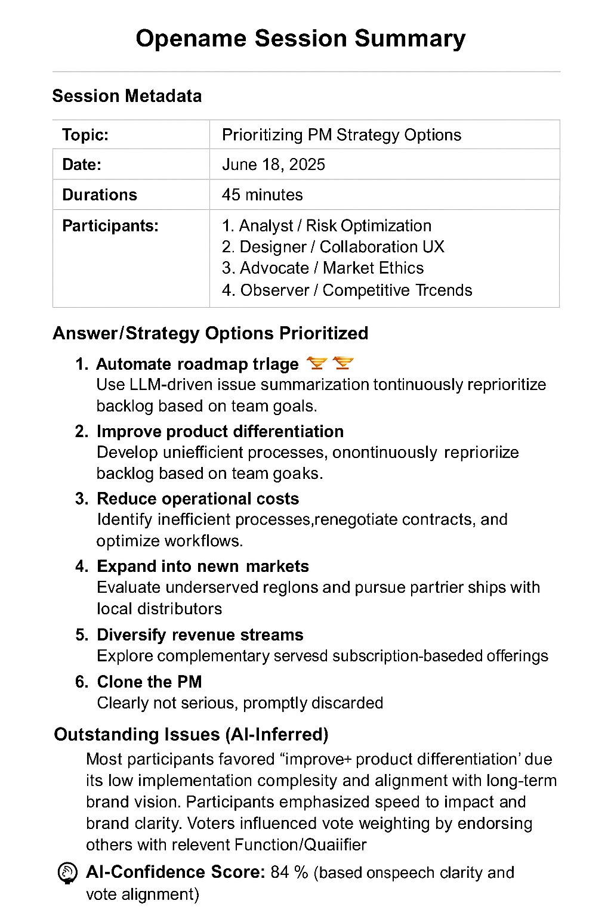

RepTag (Pier-Endorsed Function Weighting)

In Opename, participant credibility is fluid and peer-recognized. Each user enters a session with a chosen Function (e.g., Designer, Strategist, Advocate) and a Qualifier (e.g., AI Ethics, UX Systems). These tags become meaningful through a visible endorsement process.
During the session, while users vote on answer/strategy options and collaborate on edits, they may also endorse each other’s Function+Qualifier combinations using a 1–5 star system. These endorsements are represented as visible icons beside each participant’s avatar.
Endorsements are session-specific and affect vote-weighting: a participant with high endorsements in a relevant Function+Qualifier pair will have their votes carry more influence for relevant strategies. For example, a participant endorsed as "Researcher + Statistical Validation" will carry more vote weight when the strategy involves evidence or metrics.
Endorsements function similarly to RepTags but are issued by peers, not AI. These peer-issued endorsements are:
- Session-contained: They reset each session to reflect current participation.
- Live-updated: They can be changed as new insights emerge during discussion.
- Visible: Their cumulative effect appears beside each user’s avatar during the session.
Unlike BeAxa's persistent RepTags, OpeName’s endorsement model encourages dynamic recognition and re-weighting of expertise during the collaborative process, promoting real-time meritocracy during the voting session. Whether BeAxa should include voting-session RepTags into its determination of GroupBuild's site-wide RepTags, remains to be determined.

Next Steps for Implementation

- Confirm final MVP UX
- Produce each screen as a placeholder mockup
- Define database schema
- Draft OpenAPI-compatible spec
- Schedule prototyping and early testing

